### **Lab Assignment-3**

## **Aim**

To write an assembly language programming using 8086 instruction set to find the sum of odd and even numbers in the array.

### **Algorithm**

Input – number of array elements (count).  
Enter the elements to be summed in the array.

Process 🡪 Compare the odd and even numbers.  
Conclusion 🡪 By the above process, we can find the sum of odd and even numbers in the array.

## **Team Members**

Mothishwaran.C (19MID0017)  
Prashanth.S (19MID0020)  
Saksham Verma (19MID0023)  
Tharun.S (19MID0031)  
Sabarinathan R.V(19MID0057)

### **Program**

**Mounting the drive**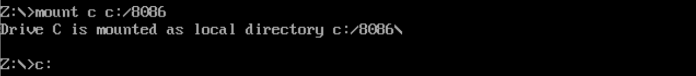

**Writing the code**  


**Compiling the Code**

**

**Debugging the .exe file**

**Execution of Start segment**

**

**Executing the remaining start segment**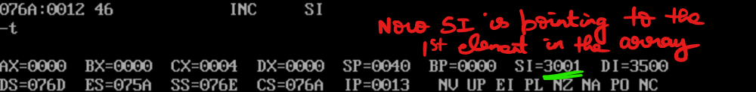

**Execution of eve segment**  
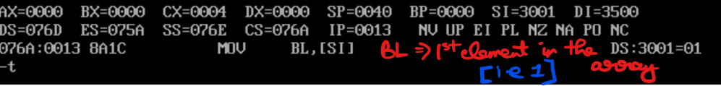

### **Video Link**

[MPU LA 3 - YouTube](https://www.youtube.com/watch?v=77qG4i-iWmc)